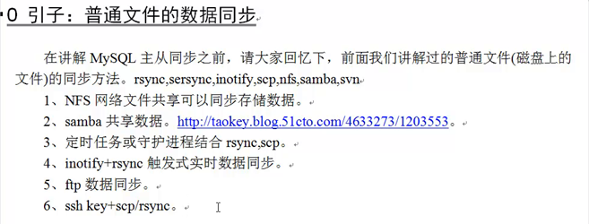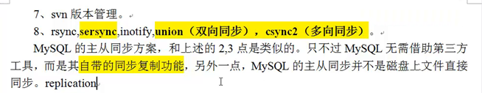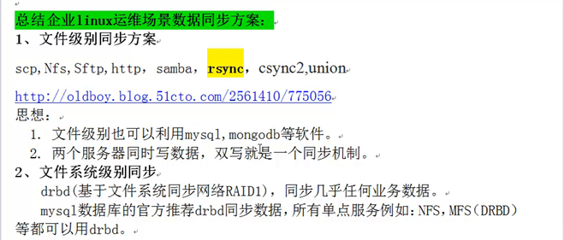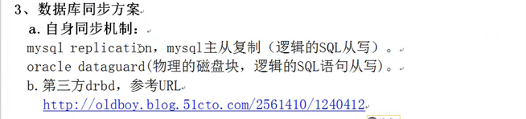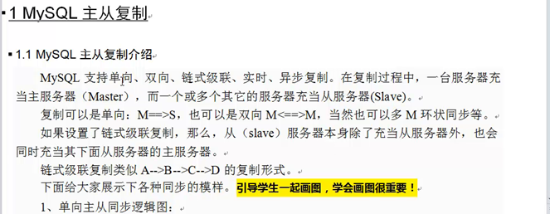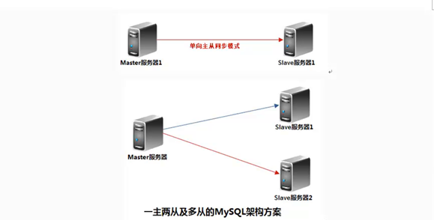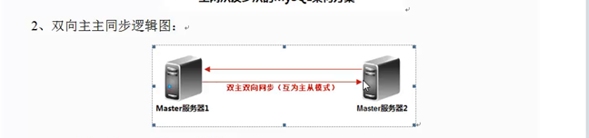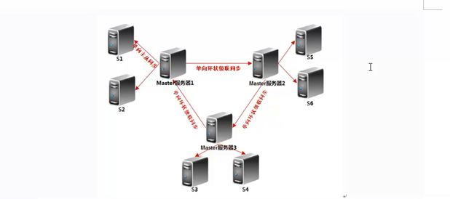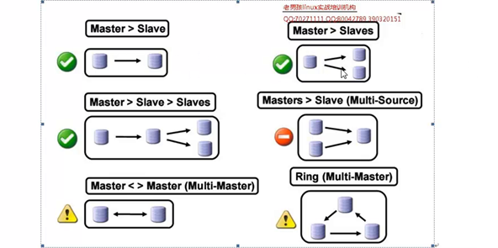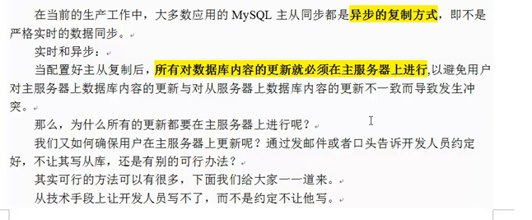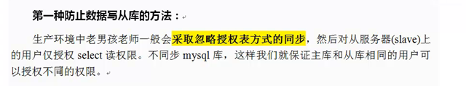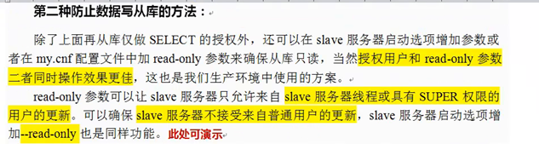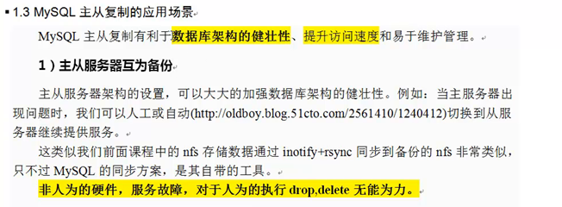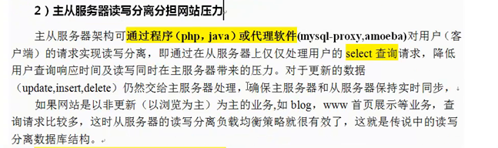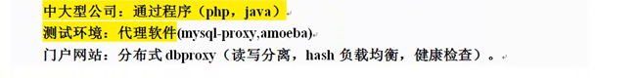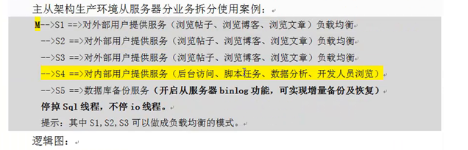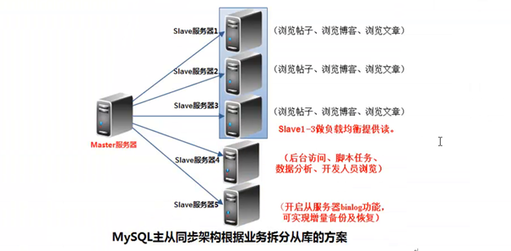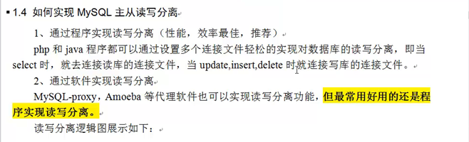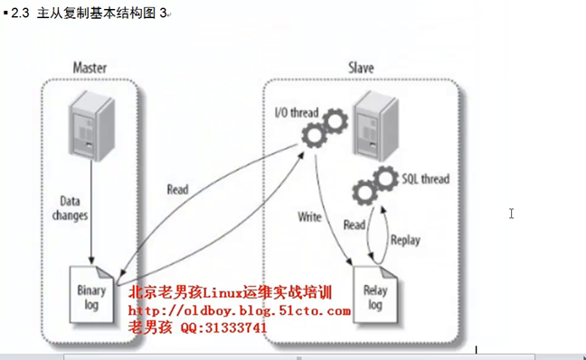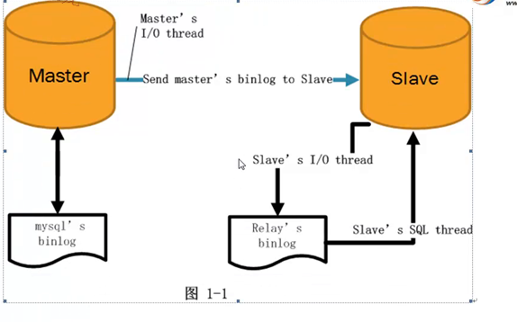

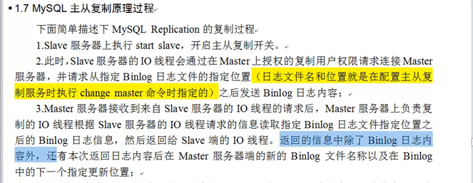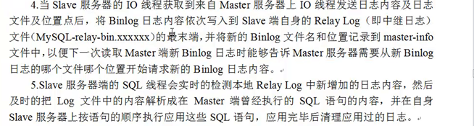

实战：我用的与文档一样，用的是多实例操作的 ip是192.168.40.142

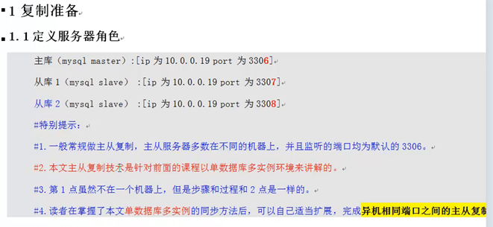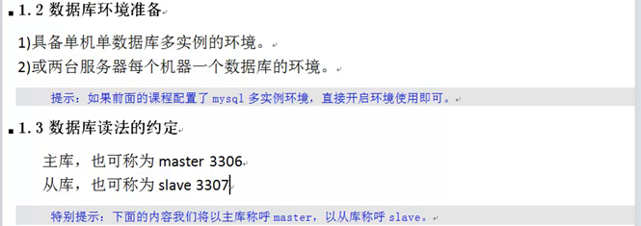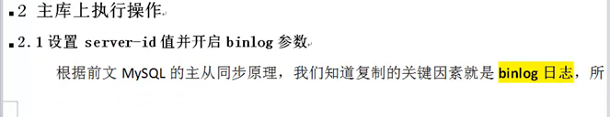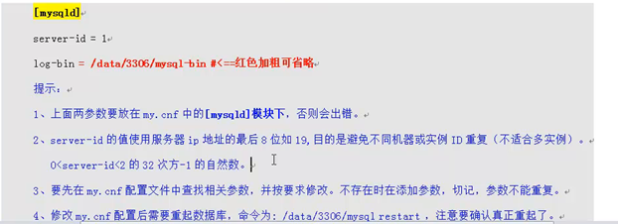

[root@c66-moban ~]# vi /data/3306/my.cnf 《《《=====编辑这个文件打开如下文件内容

log-bin = /data/3306/mysql-bin

server-id = 1

[root@c66-moban ~]# egrep "log-bin|server-id" /data/3306/my.cnf 《《《=====先保证这两个要打开

log-bin = /data/3306/mysql-bin

server-id = 1

通过两个渠道判断bin-log是否打开：

**1、通过ll /data/3306/查看**

[root@c66-moban ~]# ll /data/3306/ 《《《=====在这里边查看有如下的内容就是打开了

-rw-rw---- 1 mysql mysql 264 8月 14 14:58 mysql-bin.000001

-rw-rw---- 1 mysql mysql 107 8月 14 14:58 mysql-bin.000002

-rw-rw---- 1 mysql mysql 56 8月 14 14:58 mysql-bin.index

**2、通过mysql命令**

[root@c66-moban ~]# mysql -uroot -poldboy123 -S /data/3306/mysql.sock -e "show variables like 'log_bin';" 《《《《=====通过mysql命令查看

+---------------+-------+

| Variable_name | Value |

+---------------+-------+

| log_bin | ON |

+---------------+-------+

**从库的状态**

[root@c66-moban ~]# egrep "log-bin|server-id" /data/3307/my.cnf

#log-bin = /data/3307/mysql-bin 《《《《====这个可开可不开

server-id = 3 《《《《=====它不一样就行

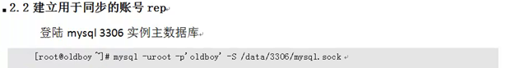 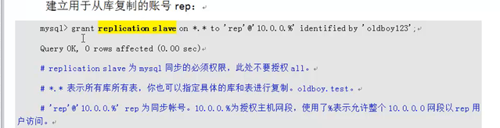

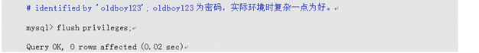

[root@c66-moban ~]# mysql -uroot -poldboy123 -S /data/3306/mysql.sock

mysql> grant replication slave on *.* to 'rep'@'192.168.40.%' identified by 'oldboy123';

Query OK, 0 rows affected (0.00 sec) 《《《=====进行授权

mysql> flush privileges; 《《《=======刷新

Query OK, 0 rows affected (0.00 sec)

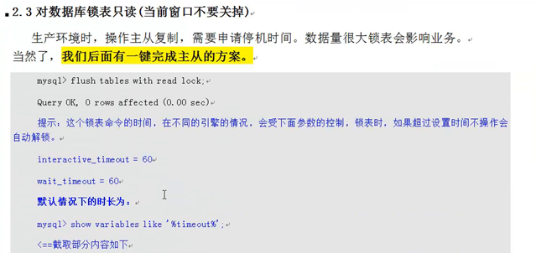

mysql> show variables like '%timeout%';

+----------------------------+----------+

| Variable_name | Value |

+----------------------------+----------+

| connect_timeout | 10 |

| delayed_insert_timeout | 300 |

| innodb_lock_wait_timeout | 120 |

| innodb_rollback_on_timeout | OFF |

| **interactive_timeout | 28800 | ======这是锁表的时间，锁不住可能就是这两个时间太小**

| lock_wait_timeout | 31536000 |

| net_read_timeout | 30 |

| net_write_timeout | 60 |

| slave_net_timeout | 3600 |

**| wait_timeout | 28800 |**

+----------------------------+----------+

10 rows in set (0.08 sec)

mysql> set global wait_timeout=10 《《《《=====这是修改时间的命令，要退出查看才生效

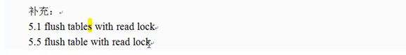

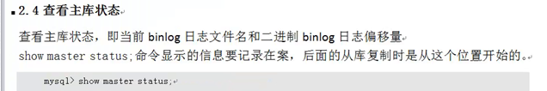

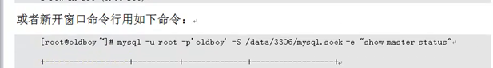

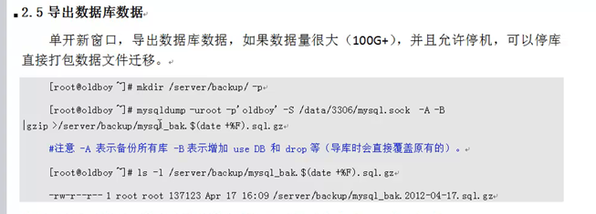

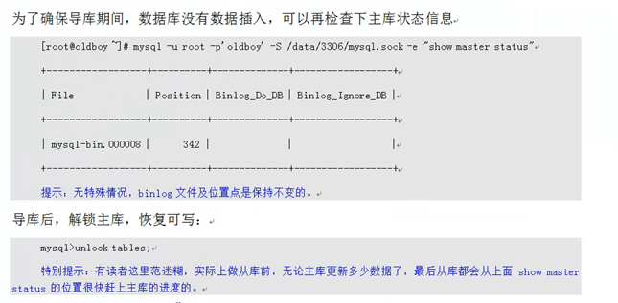

接下来开始备份数据：

备份之前先看一下

mysql> show master status; 《《《=====查看位置信息

+------------------+----------+--------------+------------------+

| File | Position | Binlog_Do_DB | Binlog_Ignore_DB |

+------------------+----------+--------------+------------------+

| **mysql-bin.000002** | **333** | | |

+------------------+----------+--------------+------------------+

1 row in set (0.00 sec)

mysql> show master logs; <<<<🡸=====查看日志信息

+------------------+-----------+

| Log_name | File_size |

+------------------+-----------+

| mysql-bin.000001 | 264 |

| mysql-bin.000002 | 333 |

+------------------+-----------+

2 rows in set (0.00 sec)

mysql> flush table with read lock; 《《《《=====在主库上锁表，加锁不让其他用户进行写入了

Query OK, 0 rows affected (0.01 sec)

然后重新开一个窗口来dump备份数据

[root@c66-moban ~]# mysqldump -uroot -poldboy123 -S /data/3306/mysql.sock -A -B --events|gzip >/opt/rep.sql.gz 《《《=====这是新开的克隆窗口进行备份主库的

[root@c66-moban ~]# mysqldump -uroot -poldboy123 -S /data/3306/mysql.sock -A -B --events --master=2 >/opt/rep.sql =====也可以这样，--master=2这样进行

[root@c66-moban ~]# vim /opt/rep.sql 《《《《=====进到里边用/CHANGE看到从什么位置开始的

CHANGE MASTER TO MASTER_LOG_FILE='mysql-bin.000002', MASTER_LOG_POS=333;

mysql> unlock tables; 《《《《=====导出数据备份之后解锁

Query OK, 0 rows affected (0.00 sec)

[root@c66-moban ~]# mysql -uroot -poldboy123 -S /data/3307/mysql.sock </opt/rep.sql <<<🡸==把从库灌回去

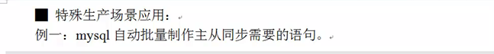

CHANGE MASTER TO

MASTER_HOST='192.168.40.142',

MASTER_PORT=3306,

MASTER_USER='rep',

MASTER_PASSWORD='oldboy123',

MASTER_LOG_FILE='mysql-bin.000002',

MASTER_LOG_POS=333;

[root@c66-moban ~]# cd /data/3307

[root@c66-moban 3307]# cd data/

[root@c66-moban data]# cat master.info 《《《=====主库给从库发送东西在这里不断更新

18

mysql-bin.000002,

333

192.168.40.142

rep

oldboy123

3306

60

0

0

1800.000

0

mysql> start slave; 《《《=====然后开启开关

Query OK, 0 rows affected (0.01 sec)

mysql> show slave status\G 《《《《=====查看配置信息

*************************** 1. row ***************************

Slave_IO_State: Waiting for master to send event

Master_Host: 192.168.40.142

Master_User: rep

Master_Port: 3306

Connect_Retry: 60

Master_Log_File: mysql-bin.000002

Read_Master_Log_Pos: 2568

Relay_Log_File: relay-bin.000002

Relay_Log_Pos: 433

Relay_Master_Log_File: mysql-bin.000002

Slave_IO_Running: **Yes**

Slave_SQL_Running: **Yes 《《《《====出现两个yes代表主从配置成功了**

Replicate_Do_DB:

Replicate_Ignore_DB: mysql

Replicate_Do_Table:

Replicate_Ignore_Table:

Replicate_Wild_Do_Table:

Replicate_Wild_Ignore_Table:

Last_Errno: 0

Last_Error:

Skip_Counter: 0

Exec_Master_Log_Pos: 2568

Relay_Log_Space: 583

Until_Condition: None

Until_Log_File:

Until_Log_Pos: 0

Master_SSL_Allowed: No

Master_SSL_CA_File:

Master_SSL_CA_Path:

Master_SSL_Cert:

Master_SSL_Cipher:

Master_SSL_Key:

Seconds_Behind_Master: 0

Master_SSL_Verify_Server_Cert: No

Last_IO_Errno: 0

Last_IO_Error:

Last_SQL_Errno: 0

Last_SQL_Error:

Replicate_Ignore_Server_Ids:

Master_Server_Id: 1

1 row in set (0.00 sec)

[root@c66-moban 3308]# mysqlbinlog relay-bin.000002 《《《《=====这就是从库查看数据写入的

检验是否成功,在主库增加数据，查看从库是否也存在数据，存在即代表成功。

[root@c66-moban 3308]# cat relay-bin.index 《《《《====查看relay文件的

/data/3308/relay-bin.000001

/data/3308/relay-bin.000002

[root@c66-moban 3308]# cat relay-log.info 《《《《===== 文件写入位置的

**/data/3308/relay-bin.000002 《《《《=====relaylog的位置**

433

mysql-bin.000002 《《《《《==io取log用的下边

2568

[root@c66-moban data]# cat master.info 《《《====查看IO写入的地方

18

mysql-bin.000002

2568

192.168.40.142

rep

oldboy123

3306

60

0

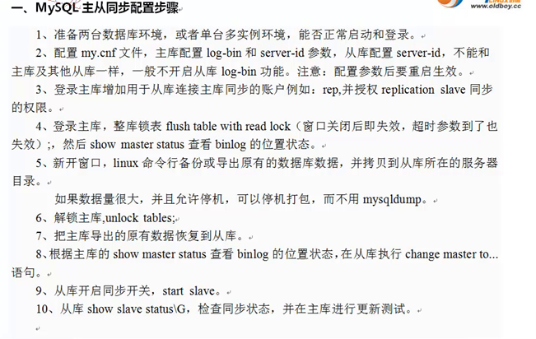

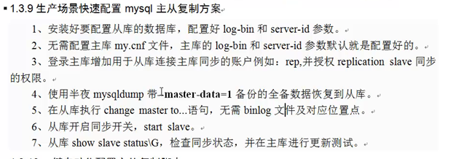

CHANGE MASTER TO

MASTER_HOST='192.168.40.142',

MASTER_PORT=3306,

MASTER_USER='rep',

MASTER_PASSWORD='oldboy123';